Genesis Template

Created: 12/08/2020

By: Eude

Email: [ajmilomo@gmail.com](mailto:ajmilomo@gmail.com)

Thank you very much for purchasing my theme. If you have any questions that you cannot find answers to in this documentation, feel free to email me via my user page content (Insert user link). Thank you!

Table of Contents

1. HTML Structure
2. CSS Files and Structure
3. Javascript
4. Sources and Credits
5. API Usage
6. HTML Structure

This theme has a simple layout throughout the entire theme. It is a one page responsive website built on the bootstrap framework. The template and its content is built in one column. Every new section in the code has been noted with a note to help the user understand where each new section begins. For example, in the demonstration below, the green coloured text are the notes.

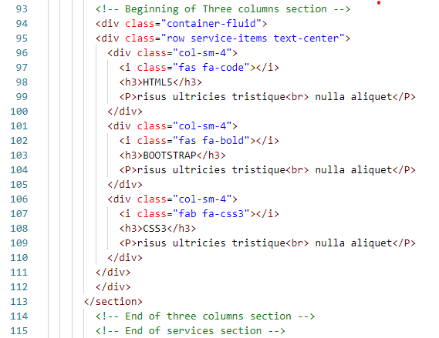

So when you want to edit the font, color and style of a specific element, you would do it like this:

.service-items h3 {

color: #somecolor;

}

B) CSS Files and Structure

In this theme, there are two types of CSS files that are being used. The first one is a responsive framework that helps the site to be easily built and responsive. Since web browsers are not all the same, this CSS file helps to show the same content regardless of which browser is being used. This CSS file also contains styling, such as anchor tags, font sizes, spacing, colors and so forth.

In the second CSS file, that is where the main styling for the page is been done. To understand where each style for each section of the page is been in place, I have noted each new section with a note that states that the styling is for this section. Each new section in the CSS will look like as follows:

/\*-- Navigation Bar --\*/

Some code for styling

/\*-- End of Navigation Bar --\*/

/\*-- Carousel Image Slider Section --\*/

Some code for styling

/\*-- End of Carousel Image Slider Section --\*/

So, if you would like to edit any styling for your page, find what you want to edit in the html file and then look for the appropriate label. From there, you can go to the CSS file to the section you were looking for by scrolling down to that specific section and look for the label that you found from the html document. Once you found it, you can edit or style the page according to your needs.

In the about us section, the image will only be displayed on a device that has a screen larger than 769px. If you would like to change this, you would go to the media queries at the bottom of the main CSS file and go to the section named “About Us Section”. You will change the background to be displayed as follows:

.right-side {

Background-image: none;

}

C) Javascript

This template uses javascript files for some of the components in the template. These files are namely:

1. Jquery
2. My custom script
3. Some plugin

1 The Jquery file helps to reduce the amount of code that would have been written. So there is no need for you to touch any of the code in the Jquery file.

2. There is only 1 specific animation used in this Template from my custom javascript file. It is used in the counter section of the templatye.

In the HTML file, you can call the javascript file like this:

<section class="counter">

The above code calls the javascript to apply the animation in this section of the template.

To apply the animation to a specific object in the template, you would call it like this:

<p class="timer">

In the above code, the class “timer” applies the animation to the p class.

Sources and credits

The following images, icons or any other file was used in this template

<a href="https://www.freepik.com/vectors/mockup">Mockup vector created by d3images - www.freepik.com</a>

I would like to thank you once again for purchasing this theme. I would be glad to help you whenever you have questions relating to this theme. There are no guarantees but I would do my utmost best to assist you. If you have a more general question relating to the themes on ThemeForest, you might consider visiting the forums and asking your question in the "Item Discussion" section.

Eude